Module1: Advanced SQL server

1.SQL Exercise -Advanced Concepts
Exercise 1: Ranking and Window Functions
SELECT
ProductID,
ProductName,
Category,
Price,
ROW_NUMBER() OVER (
PARTITION BY Category
ORDER BY Price DESC
) AS RowNum,

RANK() OVER (
PARTITION BY Category
ORDER BY Price DESC
) AS RankNum,

DENSE_RANK() OVER (
PARTITION BY Category
ORDER BY Price DESC
) AS DenseRankNum
FROM Products;
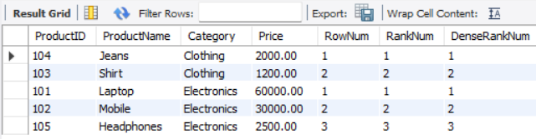
Exercise 2: Aggregation with GROUPING SETS, CUBE, and ROLLUP
-- GROUPING SETS
SELECT
c.Region,
p.Category,
SUM(od.Quantity) AS TotalQuantity,
'GROUPING SETS' AS ReportType
FROM Orders o
JOIN Customers c ON o.CustomerID = c.CustomerID
JOIN OrderDetails od ON o.OrderID = od.OrderID
JOIN Products p ON od.ProductID = p.ProductID
GROUP BY GROUPING SETS (
(c.Region, p.Category),
(c.Region),
(p.Category)
);

-- ROLLUP
SELECT
c.Region,
p.Category,
SUM(od.Quantity) AS TotalQuantity,
'ROLLUP' AS ReportType
FROM Orders o
JOIN Customers c ON o.CustomerID = c.CustomerID
JOIN OrderDetails od ON o.OrderID = od.OrderID
JOIN Products p ON od.ProductID = p.ProductID
GROUP BY ROLLUP (c.Region, p.Category);

-- CUBE
SELECT
c.Region,
p.Category,
SUM(od.Quantity) AS TotalQuantity,
'CUBE' AS ReportType
FROM Orders o
JOIN Customers c ON o.CustomerID = c.CustomerID
JOIN OrderDetails od ON o.OrderID = od.OrderID
JOIN Products p ON od.ProductID = p.ProductID
GROUP BY CUBE (c.Region, p.Category);
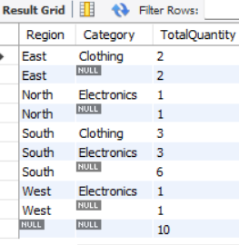
Exercise 3: CTEs and MERGE
INSERT INTO Products(ProductID, ProductName, Category, Price)
SELECT *
FROM (
SELECT ProductID, ProductName, Category, Price
FROM StagingProducts
) AS new_data
ON DUPLICATE KEY UPDATE
ProductName = new_data.ProductName,
Category = new_data.Category,
Price = new_data.Price;
Exercise 4: PIVOT and UNPIVOT
-- PIVOT
CREATE OR REPLACE VIEW ProductSalesPivot AS
SELECT
p.ProductName,
SUM(CASE WHEN MONTH(o.OrderDate) = 1 THEN od.Quantity ELSE 0 END) AS Jan,
SUM(CASE WHEN MONTH(o.OrderDate) = 2 THEN od.Quantity ELSE 0 END) AS Feb,
SUM(CASE WHEN MONTH(o.OrderDate) = 3 THEN od.Quantity ELSE 0 END) AS Mar,
SUM(CASE WHEN MONTH(o.OrderDate) = 4 THEN od.Quantity ELSE 0 END) AS Apr
FROM Orders o
JOIN OrderDetails od ON o.OrderID = od.OrderID
JOIN Products p ON od.ProductID = p.ProductID
GROUP BY p.ProductName;

SELECT * FROM ProductSalesPivot;

-- UNPIVOT
SELECT ProductName, 'Jan' AS MonthName, Jan AS Quantity FROM ProductSalesPivot
UNION ALL
SELECT ProductName, 'Feb', Feb FROM ProductSalesPivot
UNION ALL
SELECT ProductName, 'Mar', Mar FROM ProductSalesPivot
UNION ALL
SELECT ProductName, 'Apr', Apr FROM ProductSalesPivot;
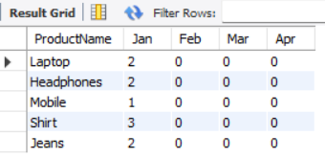

Exercise 5: Using CTE to Simplify a Query
WITH CustomerOrderCounts AS (
SELECT
CustomerID,
COUNT(*) AS OrderCount
FROM Orders
GROUP BY CustomerID
)
SELECT
c.CustomerID,
c.Name,
coc.OrderCount
FROM Customers c
JOIN CustomerOrderCounts coc
ON c.CustomerID = coc.CustomerID
WHERE coc.OrderCount > 3;
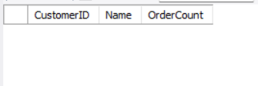

2. SQL Exercise – Index

CREATE TABLE Customers (
CustomerID INT PRIMARY KEY,
Name VARCHAR(100),
Region VARCHAR(50)
);
CREATE TABLE Products (
ProductID INT PRIMARY KEY,
ProductName VARCHAR(100),
Category VARCHAR(50),
Price DECIMAL(10,2)
);
CREATE TABLE Orders (
OrderID INT PRIMARY KEY,
CustomerID INT,
OrderDate DATE,
FOREIGN KEY (CustomerID) REFERENCES Customers(CustomerID)
);
CREATE TABLE OrderDetails (
OrderDetailID INT PRIMARY KEY,
OrderID INT,
ProductID INT,
Quantity INT,
FOREIGN KEY (OrderID) REFERENCES Orders(OrderID),
FOREIGN KEY (ProductID) REFERENCES Products(ProductID)
);

INSERT INTO Customers VALUES
(1, 'Alice', 'North'),
(2, 'Bob', 'South'),
(3, 'Charlie', 'East'),
(4, 'David', 'West');
INSERT INTO Products VALUES
(1, 'Laptop', 'Electronics', 1200.00),
(2, 'Smartphone', 'Electronics', 800.00),
(3, 'Tablet', 'Electronics', 600.00),
(4, 'Headphones', 'Accessories', 150.00);
INSERT INTO Orders VALUES
(1, 1, '2023-01-15'),
(2, 2, '2023-02-20'),
(3, 3, '2023-03-25'),
(4, 4, '2023-04-30');
INSERT INTO OrderDetails VALUES
(1, 1, 1, 1),
(2, 2, 2, 2),
(3, 3, 3, 1),
(4, 4, 4, 3);

-- Exercise 1: Before index
SELECT * FROM Products
WHERE ProductName = 'Laptop';
-- Create index on ProductName
CREATE INDEX idx_ProductName
ON Products(ProductName);
-- After index
SELECT * FROM Products
WHERE ProductName = 'Laptop';

-- Exercise 2: Before index
SELECT * FROM Orders
WHERE OrderDate = '2023-01-15';
-- Create index on OrderDate
CREATE INDEX idx_OrderDate
ON Orders(OrderDate);
-- After index
SELECT * FROM Orders
WHERE OrderDate = '2023-01-15';

-- Exercise 3: Before index
SELECT * FROM Orders
WHERE CustomerID = 1
AND OrderDate = '2023-01-15';
-- Create composite index
CREATE INDEX idx_CustomerID_OrderDate
ON Orders(CustomerID, OrderDate);
-- After index
SELECT * FROM Orders
WHERE CustomerID = 1
AND OrderDate = '2023-01-15';

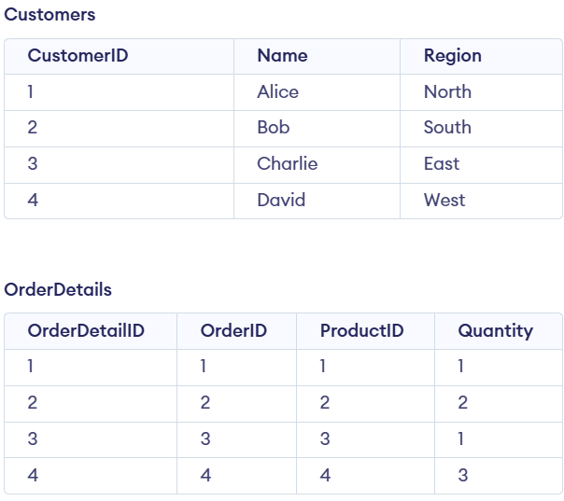
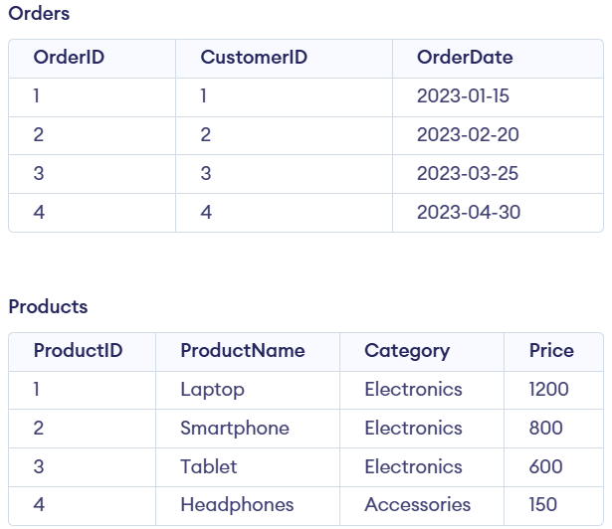
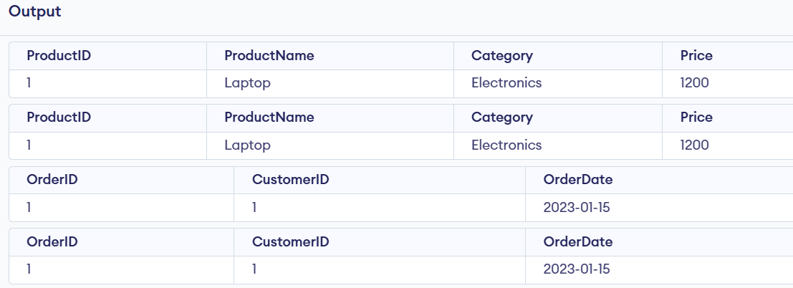
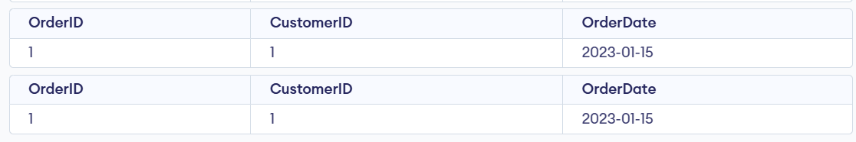

3. SQL Exercise - Views
sql exercise :
-- Create Departments table
CREATE TABLE Departments (
DepartmentID INT PRIMARY KEY,
DepartmentName VARCHAR(100)
);
-- Create Employees table
CREATE TABLE Employees (
EmployeeID INT PRIMARY KEY,
FirstName VARCHAR(50),
LastName VARCHAR(50),
DepartmentID INT,
Salary DECIMAL(10, 2),
JoinDate DATE,
FOREIGN KEY (DepartmentID) REFERENCES Departments(DepartmentID)
);

-- Insert sample Departments
INSERT INTO Departments VALUES
(1, 'HR'),
(2, 'IT'),
(3, 'Finance'),
(4, 'Marketing');
-- Insert sample Employees
INSERT INTO Employees VALUES
(101, 'Divya', 'K', 2, 30000, '2024-01-10'),
(102, 'Rahul', 'Sharma', 1, 25000, '2023-06-15'),
(103, 'Priya', 'Reddy', 3, 35000, '2022-09-20'),
(104, 'Arjun', 'Kumar', 4, 28000, '2024-03-05');
-- Exercise 1: Simple View
CREATE VIEW vw_EmployeeBasicInfo AS
SELECT
e.EmployeeID,
e.FirstName,
e.LastName,
d.DepartmentName
FROM Employees e
JOIN Departments d
ON e.DepartmentID = d.DepartmentID;
-- Exercise 2: Full Name View
CREATE VIEW vw_EmployeeFullName AS
SELECT
EmployeeID,
FirstName + ' ' + LastName AS FullName
FROM Employees;
-- Exercise 3: Annual Salary View
CREATE VIEW vw_EmployeeAnnualSalary AS
SELECT
EmployeeID,
FirstName,
LastName,
Salary,
Salary * 12 AS AnnualSalary
FROM Employees;
-- Exercise 4: Employee Report View
CREATE VIEW vw_EmployeeReport AS
SELECT
e.EmployeeID,
e.FirstName + ' ' + e.LastName AS FullName,
d.DepartmentName,
e.Salary * 12 AS AnnualSalary,
(e.Salary * 12) * 0.10 AS Bonus
FROM Employees e
JOIN Departments d
ON e.DepartmentID = d.DepartmentID;
-- View outputs
SELECT * FROM vw_EmployeeBasicInfo;
SELECT * FROM vw_EmployeeFullName;
SELECT * FROM vw_EmployeeAnnualSalary;
SELECT * FROM vw_EmployeeReport;

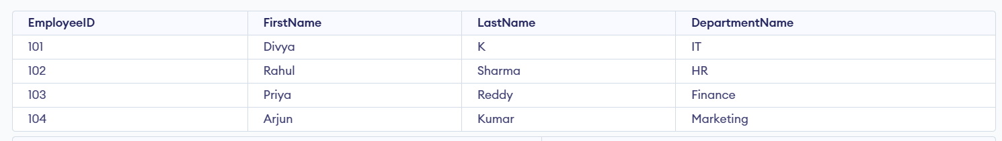
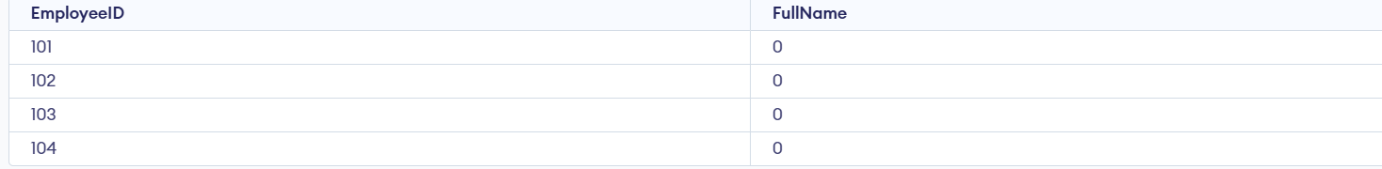
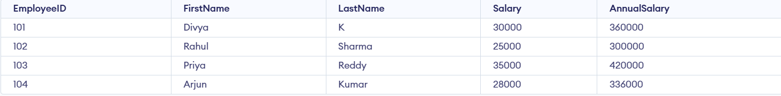
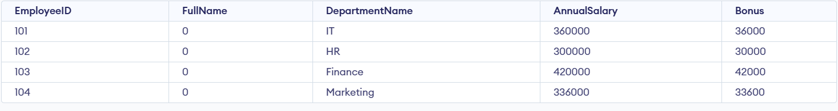

4. SQL Exercise – Stored Procedure

Exercise 1: Create a Stored Procedure
CREATE DATABASE IF NOT EXISTS EmployeeManagement;
USE EmployeeManagement;
DROP TABLE IF EXISTS Employees;
DROP TABLE IF EXISTS Departments;
CREATE TABLE Departments (
DepartmentID INT PRIMARY KEY,
DepartmentName VARCHAR(100)
);
CREATE TABLE Employees (
EmployeeID INT AUTO_INCREMENT PRIMARY KEY,
FirstName VARCHAR(50),
LastName VARCHAR(50),
DepartmentID INT,
Salary DECIMAL(10,2),
JoinDate DATE,
FOREIGN KEY (DepartmentID) REFERENCES Departments(DepartmentID)
);
INSERT INTO Departments (DepartmentID, DepartmentName) VALUES
(1, 'HR'),
(2, 'Finance'),
(3, 'IT'),
(4, 'Marketing');
INSERT INTO Employees
(FirstName, LastName, DepartmentID, Salary, JoinDate)
VALUES
('John', 'Doe', 1, 5000.00, '2020-01-15'),
('Jane', 'Smith', 2, 6000.00, '2019-03-22'),
('Michael', 'Johnson', 3, 7000.00, '2018-07-30'),
('Emily', 'Davis', 4, 5500.00, '2021-11-05');
SELECT * FROM Departments;
SELECT * FROM Employees;
DELIMITER $$
CREATE PROCEDURE sp_GetEmployeesByDepartment(
IN p_DepartmentID INT
)
BEGIN
SELECT EmployeeID,
FirstName,
LastName,
DepartmentID,
Salary,
JoinDate
FROM Employees
WHERE DepartmentID = p_DepartmentID;
END $$
DELIMITER ;
CALL sp_GetEmployeesByDepartment(3);
DELIMITER $$
CREATE PROCEDURE sp_InsertEmployee(
IN p_FirstName VARCHAR(50),
IN p_LastName VARCHAR(50),
IN p_DepartmentID INT,
IN p_Salary DECIMAL(10,2),
IN p_JoinDate DATE
)
BEGIN
INSERT INTO Employees
(FirstName, LastName, DepartmentID, Salary, JoinDate)
VALUES
(p_FirstName, p_LastName, p_DepartmentID, p_Salary, p_JoinDate);
END $$
DELIMITER ;
CALL sp_InsertEmployee(
'Robert',
'Brown',
3,
6500.00,
'2022-06-15'
);
SELECT * FROM Employees;

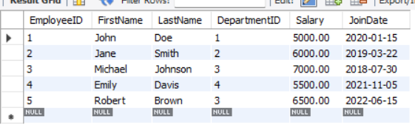

Exercise 2: Modify a Stored Procedure
DROP PROCEDURE IF EXISTS sp_GetEmployeesByDepartment;
DELIMITER $$
CREATE PROCEDURE sp_GetEmployeesByDepartment(
IN p_DepartmentID INT
)
BEGIN
SELECT
EmployeeID,
FirstName,
LastName,
DepartmentID,
Salary,
JoinDate
FROM Employees
WHERE DepartmentID = p_DepartmentID;
END $$
DELIMITER ;

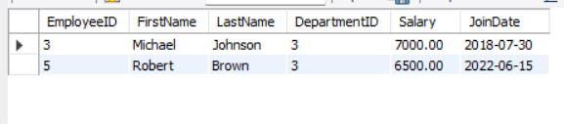

Exercise 3: Delete a Stored Procedure
DROP PROCEDURE IF EXISTS sp_GetEmployeesByDepartment;
DELIMITER $$
CREATE PROCEDURE sp_GetEmployeesByDepartment(
IN p_DepartmentID INT
)
BEGIN
SELECT EmployeeID,
FirstName,
LastName,
DepartmentID,
Salary,
JoinDate
FROM Employees
WHERE DepartmentID = p_DepartmentID;
END $$
DELIMITER ;
CALL sp_GetEmployeesByDepartment(3);
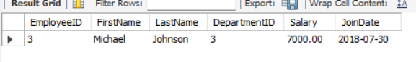

Exercise 4: Execute a Stored Procedure
DROP PROCEDURE IF EXISTS sp_GetEmployeesByDepartment;
DELIMITER $$
CREATE PROCEDURE sp_GetEmployeesByDepartment(
IN p_DepartmentID INT
)
BEGIN
SELECT EmployeeID,
FirstName,
LastName,
DepartmentID,
Salary,
JoinDate
FROM Employees
WHERE DepartmentID = p_DepartmentID;
END $$
DELIMITER ;
CALL sp_GetEmployeesByDepartment(3);
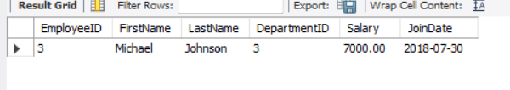

Exercise 5: Return Data from a Stored Procedure
DROP PROCEDURE IF EXISTS sp_GetEmployeeCountByDepartment;
DELIMITER $$
CREATE PROCEDURE sp_GetEmployeeCountByDepartment(
IN p_DepartmentID INT
)
BEGIN
SELECT COUNT(*) AS TotalEmployees
FROM Employees
WHERE DepartmentID = p_DepartmentID;
END $$
DELIMITER ;
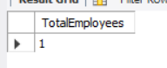

Exercise 6: Use Output Parameters in a Stored Procedure
DROP PROCEDURE IF EXISTS sp_GetTotalSalaryByDepartment;
DELIMITER $$
CREATE PROCEDURE sp_GetTotalSalaryByDepartment(
IN p_DepartmentID INT,
OUT p_TotalSalary DECIMAL(10,2)
)
BEGIN
SELECT SUM(Salary)
INTO p_TotalSalary
FROM Employees
WHERE DepartmentID = p_DepartmentID;
END $$
DELIMITER ;
CALL sp_GetTotalSalaryByDepartment(3, @TotalSalary);
SELECT @TotalSalary AS TotalSalary;
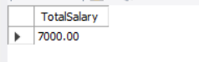

Exercise 7: Create a Stored Procedure with Multiple Parameters
DROP PROCEDURE IF EXISTS sp_UpdateEmployeeSalary;

DELIMITER $$
CREATE PROCEDURE sp_UpdateEmployeeSalary(
IN p_EmployeeID INT,
IN p_NewSalary DECIMAL(10,2)
)
BEGIN
UPDATE Employees
SET Salary = p_NewSalary
WHERE EmployeeID = p_EmployeeID;
END $$
DELIMITER ;
CALL sp_UpdateEmployeeSalary(1, 5500.00);
SELECT * FROM Employees WHERE EmployeeID = 1;
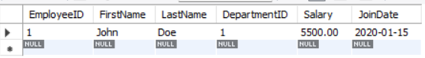

Exercise 8: Create a Stored Procedure with Conditional Logic
DROP PROCEDURE IF EXISTS sp_GiveBonus;
DELIMITER $$
CREATE PROCEDURE sp_GiveBonus(
IN p_DepartmentID INT,
IN p_BonusAmount DECIMAL(10,2)
)
BEGIN
IF p_DepartmentID IS NOT NULL THEN
UPDATE Employees
SET Salary = Salary + p_BonusAmount
WHERE DepartmentID = p_DepartmentID;
END IF;
END $$
DELIMITER ;
CALL sp_GiveBonus(1, 500.00);
SELECT * FROM Employees WHERE DepartmentID = 1;
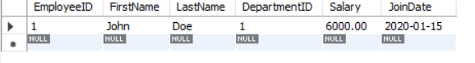

Exercise 9: Use Transactions in a Stored Procedure
DROP PROCEDURE IF EXISTS sp_UpdateSalaryTransaction;
DELIMITER $$
CREATE PROCEDURE sp_UpdateSalaryTransaction(
IN p_EmployeeID INT,
IN p_NewSalary DECIMAL(10,2)
)
BEGIN
START TRANSACTION;
UPDATE Employees
SET Salary = p_NewSalary
WHERE EmployeeID = p_EmployeeID;
COMMIT;
END $$
DELIMITER ;
CALL sp_UpdateSalaryTransaction(1, 6000.00);
SELECT * FROM Employees WHERE EmployeeID = 1;
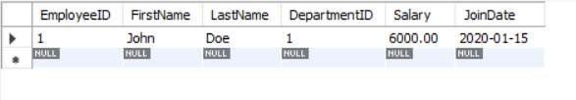

Exercise 10: Use Dynamic SQL in a Stored Procedure
DROP PROCEDURE IF EXISTS sp_GetEmployeesDynamic;

DELIMITER $$
CREATE PROCEDURE sp_GetEmployeesDynamic(
IN p_FilterColumn VARCHAR(50),
IN p_FilterValue VARCHAR(50)
)
BEGIN
SET @sql = CONCAT(
'SELECT * FROM Employees WHERE ',
p_FilterColumn,
' = ?'
);
PREPARE stmt FROM @sql;
SET @value = p_FilterValue;
EXECUTE stmt USING @value;
DEALLOCATE PREPARE stmt;
END $$
DELIMITER ;
CALL sp_GetEmployeesDynamic('DepartmentID', '3');
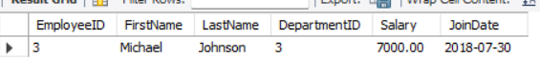

Exercise 11: Handle Errors in a Stored Procedure
DROP PROCEDURE IF EXISTS sp_UpdateSalaryWithErrorHandling;
DELIMITER $$
CREATE PROCEDURE sp_UpdateSalaryWithErrorHandling(
IN p_EmployeeID INT,
IN p_NewSalary DECIMAL(10,2)
)
BEGIN
DECLARE EXIT HANDLER FOR SQLEXCEPTION
BEGIN
ROLLBACK;
SELECT 'Error occurred while updating employee salary.' AS Message;
END;
START TRANSACTION;
UPDATE Employees
SET Salary = p_NewSalary
WHERE EmployeeID = p_EmployeeID;
COMMIT;
SELECT 'Salary updated successfully.' AS Message;
END $$
DELIMITER ;
CALL sp_UpdateSalaryWithErrorHandling(1, 6500.00);
SELECT * FROM Employees WHERE EmployeeID = 1;
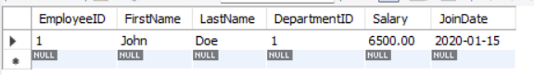

5. SQL Exercise - Funtions

CREATE TABLE Departments (
DepartmentID INT PRIMARY KEY,
DepartmentName VARCHAR(100)
);

CREATE TABLE Employees (
EmployeeID INT PRIMARY KEY,
FirstName VARCHAR(50),
LastName VARCHAR(50),
DepartmentID INT,
Salary DECIMAL(10,2),
JoinDate DATE
);
INSERT INTO Departments VALUES
(1, 'HR'),
(2, 'IT'),
(3, 'Finance');

INSERT INTO Employees VALUES
(1, 'John', 'Doe', 1, 5000.00, '2020-01-15'),
(2, 'Jane', 'Smith', 2, 6000.00, '2019-03-22'),
(3, 'Bob', 'Johnson', 3, 5500.00, '2021-07-01');
-- Annual Salary
SELECT EmployeeID, FirstName, Salary,
Salary * 12 AS AnnualSalary
FROM Employees;
-- Bonus 10%
SELECT EmployeeID, FirstName, Salary,
Salary * 0.10 AS Bonus
FROM Employees;
-- Bonus 15%
SELECT EmployeeID, FirstName, Salary,
Salary * 0.15 AS Bonus
FROM Employees;

-- IT Department
SELECT *
FROM Employees
WHERE DepartmentID = 2;

-- Finance Department
SELECT *
FROM Employees
WHERE DepartmentID = 3;

-- Annual salary of Employee 1
SELECT EmployeeID, FirstName, Salary,
Salary * 12 AS AnnualSalary
FROM Employees
WHERE EmployeeID = 1;

-- Total Compensation
SELECT EmployeeID, FirstName, Salary,
(Salary * 12) + (Salary * 0.15) AS TotalCompensation
FROM Employees;

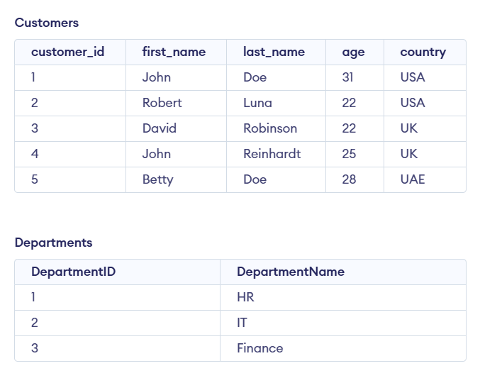
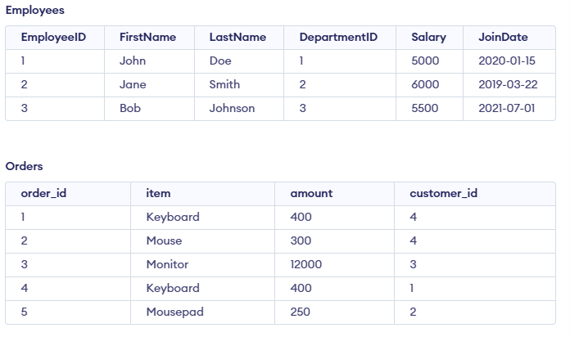

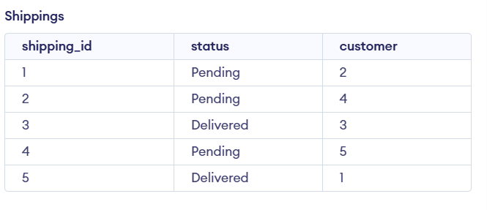
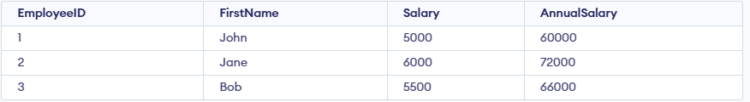
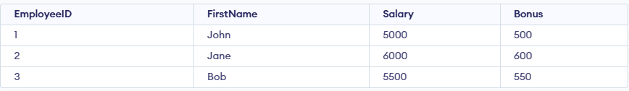
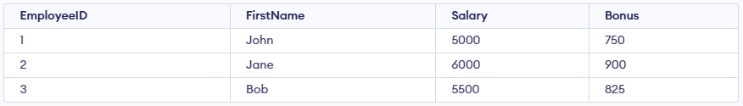
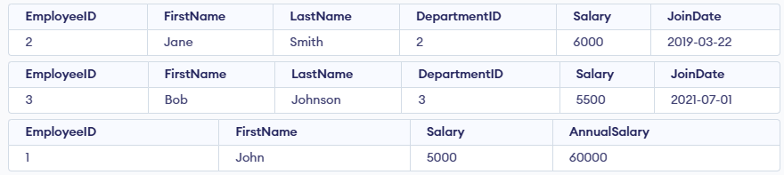
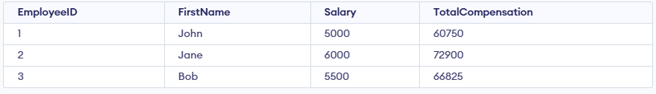

6. SQL Exercise-Triggers
Exercise 1: Create an After Trigger
create database db;
use db;
CREATE TABLE Departments (
DepartmentID INT PRIMARY KEY,
DepartmentName VARCHAR(100)
);
CREATE TABLE Employees (
EmployeeID INT PRIMARY KEY,
FirstName VARCHAR(50),
LastName VARCHAR(50),
DepartmentID INT,
Salary DECIMAL(10,2),
JoinDate DATE,
FOREIGN KEY (DepartmentID) REFERENCES Departments(DepartmentID)
);
INSERT INTO Departments (DepartmentID, DepartmentName) VALUES
(1, 'HR'),
(2, 'Finance'),
(3, 'IT'),
(4, 'Marketing');
INSERT INTO Employees (EmployeeID, FirstName, LastName, DepartmentID, Salary, JoinDate) VALUES
(1, 'John', 'Doe', 1, 5000.00, '2022-01-15'),
(2, 'Jane', 'Smith', 2, 6000.00, '2021-03-22'),
(3, 'Michael', 'Johnson', 3, 7000.00, '2020-07-30'),
(4, 'Emily', 'Davis', 4, 5500.00, '2019-11-05');
CREATE TABLE EmployeeChanges (
ChangeID INT AUTO_INCREMENT PRIMARY KEY,
EmployeeID INT,
OldSalary DECIMAL(10,2),
NewSalary DECIMAL(10,2),
ChangeDate DATETIME DEFAULT CURRENT_TIMESTAMP
);
DELIMITER $$
CREATE TRIGGER trg_AfterSalaryUpdate
AFTER UPDATE ON Employees
FOR EACH ROW
BEGIN
IF OLD.Salary <> NEW.Salary THEN
INSERT INTO EmployeeChanges
(EmployeeID, OldSalary, NewSalary)
VALUES
(OLD.EmployeeID, OLD.Salary, NEW.Salary);
END IF;
END$$
DELIMITER ;
UPDATE Employees
SET Salary = 5500.00
WHERE EmployeeID = 1;
SELECT * FROM EmployeeChanges;
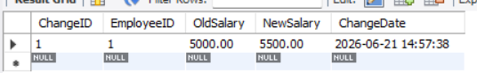

Exercise 2: Create an Instead of Trigger
DELIMITER $$
CREATE TRIGGER trg_PreventEmployeeDelete
BEFORE DELETE ON Employees
FOR EACH ROW
BEGIN
SIGNAL SQLSTATE '45000'
SET MESSAGE_TEXT = 'Deletion of employee records is not allowed';
END$$
DELIMITER ;
DELETE FROM Employees
WHERE EmployeeID = 1;
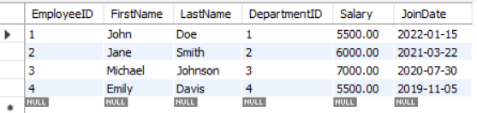

Exercise 3: Create a Logon Trigger
CREATE TRIGGER trg_RestrictLogin
ON ALL SERVER
FOR LOGON
AS
BEGIN
IF DATEPART(HOUR, GETDATE()) >= 2
AND DATEPART(HOUR, GETDATE()) < 3
BEGIN
ROLLBACK;
RAISERROR ('Login is not allowed during maintenance hours (2 AM - 3 AM).', 16, 1);
END
END;
GO

Output:
Login is not allowed during maintenance hours (2 AM - 3 AM).
Login failed.

Exercise 4: Modify a Trigger using SSMS
DELIMITER $$
CREATE TRIGGER trg_AfterSalaryUpdate
AFTER UPDATE ON Employees
FOR EACH ROW
BEGIN
IF NEW.Salary > OLD.Salary THEN
INSERT INTO EmployeeChanges
(EmployeeID, OldSalary, NewSalary)
VALUES
(OLD.EmployeeID, OLD.Salary, NEW.Salary);
END IF;
END$$
DELIMITER ;
UPDATE Employees
SET Salary = 6500.00
WHERE EmployeeID = 2;
SELECT * FROM EmployeeChanges;
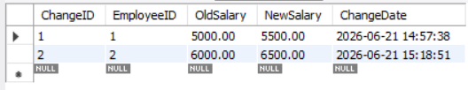

Exercise 5: Delete a Trigger
DROP TRIGGER IF EXISTS trg_AfterSalaryUpdate;
SHOW TRIGGERS;

Exercise 6: Create a Trigger to Update a Computed Column
ALTER TABLE Employees
ADD COLUMN AnnualSalary DECIMAL(12,2);

UPDATE Employees
SET AnnualSalary = Salary * 12
WHERE EmployeeID > 0;

DELIMITER $$

CREATE TRIGGER trg_UpdateAnnualSalary
BEFORE UPDATE ON Employees
FOR EACH ROW
BEGIN
SET NEW.AnnualSalary = NEW.Salary * 12;
END$$

DELIMITER ;

UPDATE Employees
SET Salary = 8000.00
WHERE EmployeeID = 3;

SELECT EmployeeID, FirstName, Salary, AnnualSalary
FROM Employees;
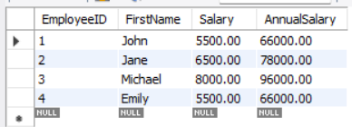

7. SQL Exercise - Cursors

CREATE TABLE Departments (
DepartmentID INT PRIMARY KEY,
DepartmentName VARCHAR(100)
);

CREATE TABLE Employees (
EmployeeID INT PRIMARY KEY,
FirstName VARCHAR(50),
LastName VARCHAR(50),
DepartmentID INT,
Salary DECIMAL(10,2),
JoinDate DATE
);
INSERT INTO Departments VALUES
(1,'HR'),
(2,'IT'),
(3,'Finance');

INSERT INTO Employees VALUES
(1,'John','Doe',2,5000,'2020-01-15'),
(2,'Jane','Smith',1,6000,'2019-03-22'),
(3,'Bob','Johnson',3,5500,'2021-07-30');
-- Instead of CURSOR (not supported in MySQL/SQLite),
-- we directly fetch row-by-row result using SELECT

SELECT
EmployeeID,
FirstName,
LastName,
DepartmentID,
Salary,
JoinDate
FROM Employees;
SELECT
e.EmployeeID,
e.FirstName,
e.LastName,
d.DepartmentName,
e.Salary,
e.JoinDate
FROM Employees e
JOIN Departments d
ON e.DepartmentID = d.DepartmentID;

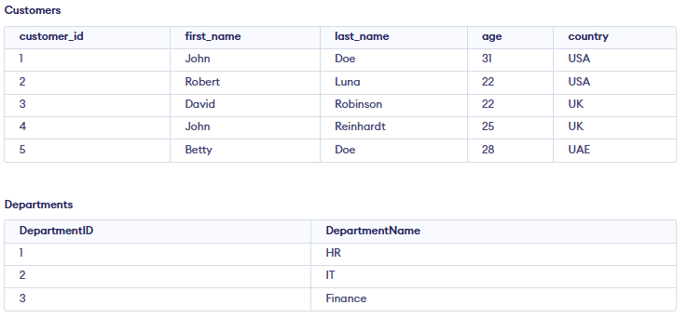
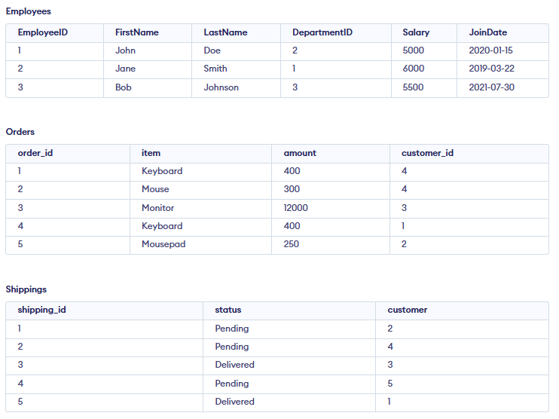

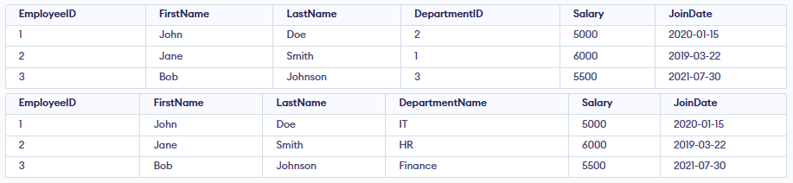

8. SQL Exercise – Exception handling

CREATE TABLE Departments (
DepartmentID INT PRIMARY KEY,
DepartmentName TEXT NOT NULL
);

CREATE TABLE Employees (
EmployeeID INT PRIMARY KEY,
FirstName TEXT,
LastName TEXT,
Email TEXT UNIQUE,
Salary REAL,
DepartmentID INT
);

CREATE TABLE AuditLog (
LogID INTEGER PRIMARY KEY AUTOINCREMENT,
Action TEXT,
ErrorMessage TEXT,
ActionDate DATETIME DEFAULT CURRENT_TIMESTAMP
);
INSERT INTO Departments VALUES (1, 'IT');
INSERT INTO Departments VALUES (2, 'HR');
-- VALID INSERT
INSERT INTO Employees VALUES (101, 'John', 'Doe', 'john@gmail.com', 5000, 1);

-- LOW SALARY ERROR SIMULATION
INSERT INTO AuditLog(Action, ErrorMessage)
VALUES ('Add Employee', 'Warning: Salary too low (simulated)');

-- INVALID SALARY SIMULATION
INSERT INTO AuditLog(Action, ErrorMessage)
VALUES ('Add Employee Failed', 'Salary must be greater than zero (simulated)');
INSERT INTO AuditLog(Action, ErrorMessage)
VALUES ('Throw Simulation', 'Error re-raised (simulated behavior)');
-- SUCCESS UPDATE
UPDATE Employees
SET DepartmentID = 2
WHERE EmployeeID = 101;

-- ERROR LOG (department not found simulation)
INSERT INTO AuditLog(Action, ErrorMessage)
VALUES ('Transfer Failed', 'Department does not exist (simulated)');

BEGIN TRANSACTION;

INSERT INTO Employees VALUES (102, 'Alice', 'Smith', 'alice@gmail.com', 3000, 1);
INSERT INTO Employees VALUES (103, 'Bob', 'Marley', 'bob@gmail.com', 4500, 2);
INSERT INTO Employees VALUES (104, 'Eva', 'Brown', 'eva@gmail.com', 3500, 1);

COMMIT;
INSERT INTO AuditLog(Action, ErrorMessage)
VALUES ('Batch Insert', 'Transaction completed successfully')
SELECT * FROM Departments;
SELECT * FROM Employees;
SELECT * FROM AuditLog;
